Install terraform on Ubuntu 20.04, CentOS 8, MacOS, Windows 10, Fedora 33, Red hat

8 and Solaris 11

In this guide, we will focus on Installation of Terraform on a various operating system such as Ubuntu 20.04, CentOS 8, Fedora 33, Red Hat 8, and Solaris.

1. Install Terraform on Ubuntu 20.04, CentOS 8, Fedora 33, Red Hat 8 or Solaris
2. Install Terraform on Windows 10
3. Install Terraform on MacOS

Later we are also going to see How to Upgrade Terraform using tfenv?

1. Upgrade Terraform using tfenv
2. Upgrade Terraform to Specific version using tfenv
3. Uninstall the Terraform

# Installing Terraform on Ubuntu 20.04, CentOS 8, Fedora 33, Red Hat 8, or Solaris

The instructions and command for installing Terraform on Ubuntu 20.04 OR CentOS 8 OR Fedora 33|32|31 is almost same. You only need to pay attention to which version of the host OS you are choosing. Is it 32 bit or 64 Bit?

## Install the Terraform using official Package distribution

Ubuntu

1. Update apt-get package manager
2. Install official hashicorp repository

[BASH](https://jhooq.com/terraform-index/)

[sudo apt-get update && sudo apt-get insta](https://jhooq.com/)[ll -y gnupg](https://jhooq.com/ansible-video-index/) [software-prop](https://jhooq.com/kubernetes-index/)e[rties-common](https://jhooq.com/terraform-index/)

BASH

curl -fsSL https://apt.releases.hashicorp.com/gpg | sudo apt-key add -

BASH

sudo apt-add-repository "deb [arch=amd64] https://apt.releases.hashicorp.com $(l

1. Install terraform

BASH

sudo apt-get update && sudo apt-get install terraform

Centos

1. Install yum-config-manager

BASH

sudo yum install -y yum-utils

1. Add official HashiCorp Linux repository

BASH

sudo yum-config-manager --add-repo https://rpm.releases.hashicorp.com/RHEL/hashi

[3. Install](https://jhooq.com/)

BASH

sudo yum -y install terraform

Fedora

1. Install yum-config-manager

BASH

sudo dnf install -y dnf-plugins-core

1. Add official HashiCorp Linux repository

BASH

sudo dnf config-manager --add-repo https://rpm.releases.hashicorp.com/fedora/has

1. Install terraform

BASH

sudo dnf -y install terraform

## The manual way to install Terraform

To install terraform manually you first need to download the terraform zip file from the hasicorp official website and to download zip file on the linux machine you need wget utility.

1. Ubuntu 20.04 | 18.10 | 18.04 :

[In case if you do not have wget then use the](https://jhooq.com/) f[ollowing co](https://jhooq.com/ansible-video-index/)[mmand to insta](https://jhooq.com/kubernetes-index/)[ll it -](https://jhooq.com/terraform-index/)

BASH

sudo apt-get install wget unzip

2. CentOS 8 | 7 :

BASH

sudo yum install wget unzip

3. Fedora 33 | 32 | 31 :

bash sudo dnf install wget

## Download the terraform.zip file

1. Goto [Terrafrom.io](https://www.terraform.io/)
2. Click on [Download CLI](https://www.terraform.io/downloads.html) and for Ubuntu

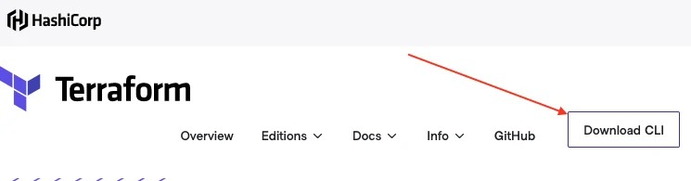

Terraform.io for terraform installation on Ubuntu

system architecture choose a suitable option (32-bit | 64-bit | Arm | Arm64). I choose the 64 bit

[3. On the download page you will](https://jhooq.com/) find an option Linux, so based on your operating



Download terrafrom for 64 bit Ubuntu

1. Right-click on 64-Bit option then click on Copy Link Location (We need to copy the download link)

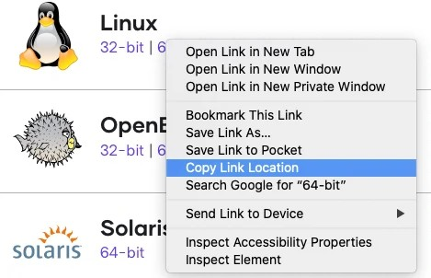

Copy Link location for downloading the terraform

1. Open Terminal and use the wget command followed by the link which you copied in the previous step.
2. After successful download you will see a ZIP file inside your directory

[BASH](https://jhooq.com/terraform-index/)

[wget https://releases.hashicorp.com/terr](https://jhooq.com/)[aform/0.14.](https://jhooq.com/ansible-video-index/)[7/terraform_0.](https://jhooq.com/kubernetes-index/)1[4.7_linux_amd](https://jhooq.com/terraform-index/)



terraform ZIP

## Unzip and move the file to '/usr/local/bin'

1. Unzip the terraform ZIP file

BASH

unzip terraform_0.14.7_linux_amd64.zip

1. After the UNZIP you should see a file named terraform
2. Move the file terraform to /usr/local/bin

BASH

sudo mv terraform /usr/local/bin/

## Verify the Terraform installation on Ubuntu

You can confirm the installation by running the following command

It should return you with the version which you have installed. In my case, the version was - Terraform v0.14.7

[BASH](https://jhooq.com/terraform-index/)

[terrafrom -v](https://jhooq.com/)

BASH

Terraform v0.14.7

# 2. Installing Terraform on Windows 10

## Download the terraform.zip file

1. Head over to [Terrafrom.io](https://www.terraform.io/) and click on (https:/ www.terraform. io/downloads.html)
2. Scroll down the page and look for the Windows option. After that you need to select the version 32 Bit | 64 Bit. (In my case I had 64 Bit Windows 10, so I choose 64 Bit option for download)

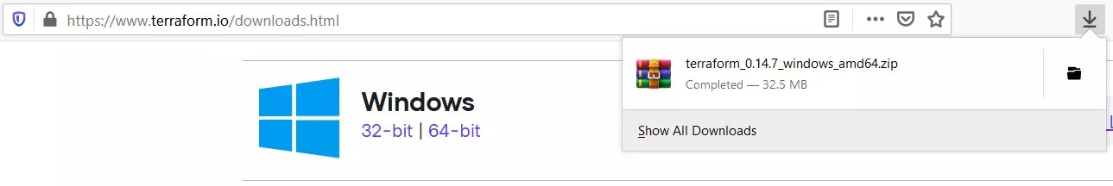

Download Terraform 64 bit for Windows 10

1. Once you click on either 32 Bit or 64 Bit, it will download a ZIP file for you.
2. let's move the ZIP file to some good location. In my case, I moved the file to C:\Terra form (You can move the ZIP file to any location of your choice but always remember the path onto which you are moving the file)

[Move and Extract the Terraform ZI](https://jhooq.com/)P [file](https://jhooq.com/ansible-video-index/)

1. Extract the Terraform ZIP file (After the extraction it should have one file *terraform. zip*)

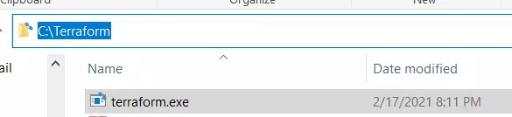

Path of terraform.exe after extracting it on windows 10

## Add the Terraform directory PATH to Windows 10 environment variable

1. Copy the path of the folder where you placed terraform.exe (In my case the path was *C:\Terraform*)
2. Goto Start Menu and type in the Environment Variables in the search box and then click on Open

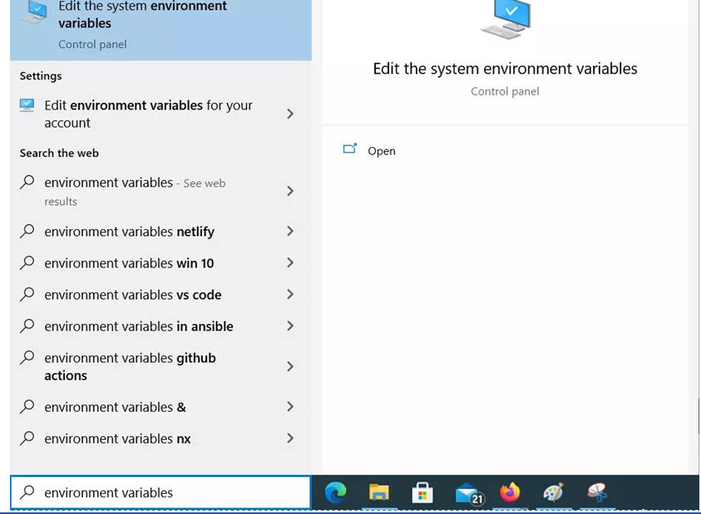

Update environment variable for terrform installation on windows 10

1. Once you open the environment variables window you need to click on Environment Variables (You can find it at the bottom of the window)

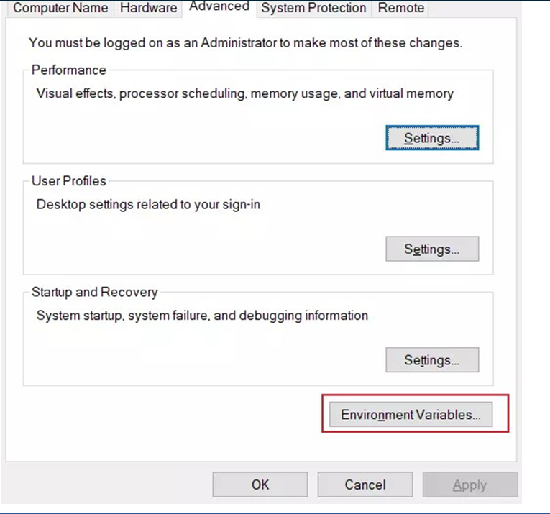

Open environment variables for installtion of terraform in windows 10

1. Goto -> System Variables then look for the system variable named Path

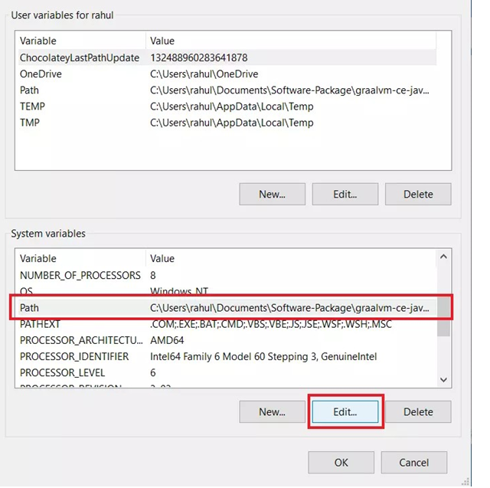

Edit PATH environment variable for installation of Terraform on Windows 10

1. Click on Edit and it should open another window. Click on new and past the path of your terraform directory

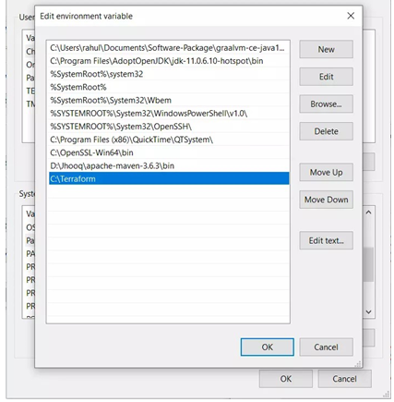

Add new Environment variable for terraform installation

## Verify the Terraform installation on Windows 10

BASH

terraform -v

[You can verify the installation by opening th](https://jhooq.com/)e [command pr](https://jhooq.com/ansible-video-index/)[ompt and then t](https://jhooq.com/kubernetes-index/)[yping the](https://jhooq.com/terraform-index/)

[following command -](https://jhooq.com/)

If you have successfully installed the terraform then it should return you with the version number.

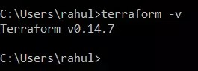

Terraform version command on windows 10 command prompt

# 3. Installing Terraform on MacOS

## Install the Terraform on MacOS using brew

This is one of my favorite ways to install any package on my macOS, but here are the steps for installing Terraform using [HomeBrew](https://brew.sh/)

1. Use the following Homebrew command it will install the Terraform for you.

BASH

brew install terraform



BASH

==> Downloading https://homebrew.bintray.com/bottles/terraform-0.14.3.catalin

==> Downloading from https://d29vzk4ow07wi7.cloudfront.net/1172ae8f9a7ac2bed8

1. You can download the [Terrafrom.io](https://www.terraform.io/) from [Download CLI](https:/ www.terraform. io/downloads.html)
2. Extract the downloaded ZIP file
3. Move the ZIP file using the following command

BASH

sudo mv $HOME/Downloads/terraform /usr/local/bin/

## Verify the Terraform installation on macOS

You can verify the Installation of Terraform on macOS by running the following command

terraform -v

It should return you with the version which you have installed onto your macOS

BASH

Terraform v0.14.3

## Install tfenv on Ubuntu 20.04 | CentOS 8 | Fedora 33 | Red hat 8 | Solaris 11

The installation of tfenv is pretty straight forward but you should at least know how to do git clone or you should be familiar with git.

1. Clone the tfenv repo

BASH

git clone https://github.com/tfutils/tfenv.git ~/.tfenv

1. Add ~/.tfenv/bin to your $PATH

BASH

echo 'export PATH="$HOME/.tfenv/bin:$PATH"' >> ~/.bash_profile

1. Create symlink for ~/.tfenv/bin/*

BASH

mkdir -p ~/.local/bin/

BASH

. ~/.profile

BASH

which tfenv

* 1. Verify the tfenv installation

You can use the following command to verify the installation of tfenv

tfenv

It should return you with version

tfenv 2.2.0

Usage: tfenv <command> [<options>]

Commands:

install Install a specific version of Terraform use Switch a version to use

uninstall Uninstall a specific version of Terraform list List all installed versions

list-remote List all installable versions version-name Print current version

init Update environment to use tfenv correctly.

## List available version using $ tfenv list-remote

Run the following command to check the available version

[Before upgrading Terraform version, you sho](https://jhooq.com/)[uld check](https://jhooq.com/ansible-video-index/) w[hich versions o](https://jhooq.com/kubernetes-index/)[f Terraform ar](https://jhooq.com/terraform-index/)[e](https://jhooq.com/youtube)

[available.](https://jhooq.com/)

BASH

tfenv list-remote

You will see the following output based on the latest available version -

BASH

0.15.0-beta1

0.15.0-alpha20210210

0.15.0-alpha20210127

0.15.0-alpha20210107

0.14.7

0.14.6

0.14.5

0.14.4

0.14.3

0.14.2

0.14.1

0.14.0

## Install the latest version of Terraform

There is the default latest command provided by tfenv which will install the latest version of Terraform onto your system

BASH

tfenv install latest

If you really want to upgrade to a specific version of Terraform then always keep the correct version of Terraform handy with you. (At the time of writing this article the latest stable version of Terraform is 0.14.7)

BASH

tfenv install 0.14.7

There is one more feature provided by the tfenv. If you want to upgrade to the latest version of some specific release for example you want the latest version from 0.14 release then you can do it by running -

BASH

tfenv install latest:^0.14

## 5.1 Change terraform version (If you have already installed multiple versions of Terraform)

Let's say you have installed multiple version(0.14.7, 0.14.6, 0.14.5) of terraform and now you want to switch between the versions then use the following command to achieve that

BASH

tfenv use 0.14.6

The above command will switch to terraform to version 0.14.6

BASH

tfenv use

[But if you use only terraform use then it will](https://jhooq.com/) s[witch the l](https://jhooq.com/ansible-video-index/)a[test version of](https://jhooq.com/kubernetes-index/) [Terraform.](https://jhooq.com/terraform-index/)

The above command will switch to version 0.14.7 because at the time of writing this article 0.14.7 is latest the version provided by terraform

# 6. Uninstall the Terraform

The uninstallation command of the Terraform is very simple -

BASH

tfenv uninstall 0.14.7

BASH

Uninstall Terraform v0.14.7

Terraform v0.14.7 is successfully uninstalled

[Reserved](https://jhooq.com/)